Sinking an Above Ground Pool
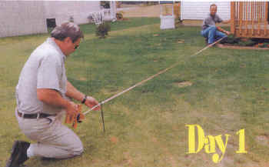  Step 1: Measure Your Site | 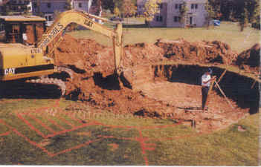  Step 2: Excavate | 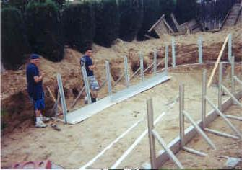  Step 3: Set-Up the Outside Perimeter
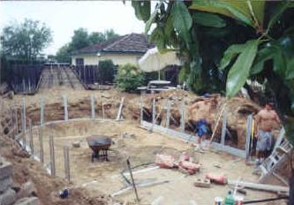  Step 4: Lay Bracing | 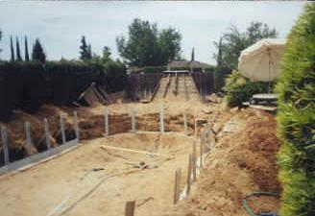  Step 5 Excavate The Deep End | 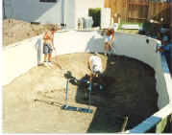  Step 6: Smooth the Pool Bottom
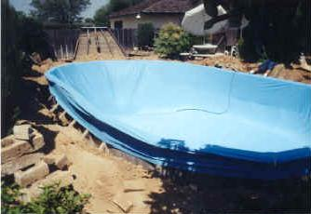  Step 7:Stretch the Liner | 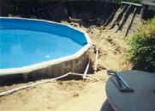  Step 8: Plumb the Pool | 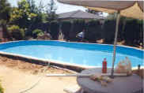  Step 9: Fill the Pool, and then Back Fill Dirt.
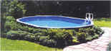 |  | 

